Introduction for Project B

**Aim of this project:** Create a simple Linux application that demonstrates an application to application communication using zeromq library (https://zeromq.org/ ). The communication can be a one-way communication, from application A to application B.

Application A will be sending a string that contains the current timestamp in the format of “YYYY-MM-DD HH:MM:SS”. Application B will just simple print it out. There is a C library for zeromq called czmq that makes it easier to use C

**Design of the system:**

Client

（Application A）

Listening port 5555

Sending Time via port 5555

Server

（Application B）

Sending feedback

Display received Feed back

Display received message

**Code description:**

The code example can be divided into these parts:

1. Initiation of a session via the TCP protocol using port 5555

*void *context = zmq_ctx_new ();*

*void *requester = zmq_socket (context, ZMQ_REQ);*

*zmq_connect (requester, "tcp://localhost:5555");*

1. Send /Receive message

*zmq_send (requester, formatedTime, 20, 0);*

*zmq_recv (requester, buffer, 10, 0);//receive feed back*

1. Closing of the connection

*zmq_close (requester); //close the link*

*zmq_ctx_destroy (context);*

**Compile and run**:

**Command**： *gcc -I/usr/include  Server.c -L/usr/lib/x86_64-linux-gnu -lzmq -o* *ZMQCS*

*gcc -I/usr/include  Client.c -L/usr/lib/x86_64-linux-gnu -lzmq -o ZMQC*

In will generate the executable files: ZMQCS (***for server, application B***)

And: ZMQC (***for client, application A***)

Run the file by **command**: ./ ZMQCS and ./ZMQC in two terminals,

Results will show as:

Applicaion B

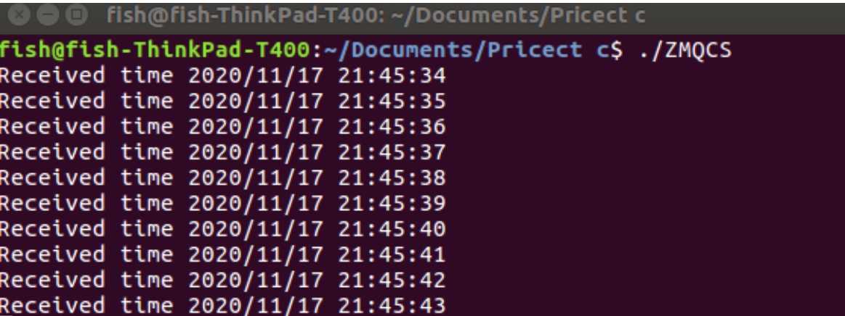

Application A:

